A Project Report on

“RAKSHA – SAFE ROUTE APPLICATION”
Submitted In Partial Fulfillment of the Requirement for the Award of the Degree Of

Bachelor of Technology (Computer Science & Engineering)
Submitted to


Dr. A.P.J. Abdul Kalam Technical University, Uttar Pradesh, Lucknow

Submitted by
Anurag Rana (2203330100036)
Aayush Soam (2203330100005)
Gaurav (2203330100068)
Harishankar Tiwari (2203330100070)

Under the Supervision of

Ms. Deepa Solanki

Designation Department of CSE

Raj Kumar Goel Institute of Technology and Management,Ghaziabad

2025 - 2026

DECLARATION

We, Anurag Rana (2203330100036), Gaurav (2203330100068), Aayush Soam (2203330100005) and Harishankar Tiwari (2203330100070) students of Bachelor of Technology, Computer Science & Engineering department at Raj Kumar Goel Institute of Technology & Management, Ghaziabad hereby declare that the work presented in this project titled “RAKSHA” is outcome of our own work, is bonafide, correct to the best of our knowledge and this work has been carried out taking care engineering ethics. We have completely taken care in acknowledging the contribution of others in this academic work. We further declare that in case of any violation of intellectual property rights or copyrights found at any stage, we as the candidates will be solely responsible for the same.

Place: Ghaziabad (U.P) Anurag Rana (2203330100036) Aayush soam (2203330100005)
Gaurav (2203330100068)
Harishankar Tiwari (2203330100070)

B.Tech. (CSE)
RKGITM, Ghaziabad

CERTIFICATE

This is to certify that the project report entitled “RAKSHA”, submitted by Anurag Rana (2203330100036), Aayush soam (2203330100005), Gaurav (2203330100068) and Harishankar Tiwari (2203330100070) in partial fulfillment of the requirement for the award of the degree of Bachelor of Technology in Computer Science & Engineering to Dr. A.P.J. Abdul Kalam Technical University, Uttar Pradesh, Lucknow is a record of student’s own work carried out under our supervision and guidance.

Ms. Deepa Solanki Ms. Nidhi Garg
(Project Guide) (Head of Department)

Department of CSE

ACKNOWLEDGEMENT

The present work will remain incomplete unless we express our feelings of gratitude towards a number of persons who delightfully co-operated with us in the process of this work.
First of all we would like to thank our HOD Ms. Nidhi Garg, RKGITM, Ghaziabad for his encouragement and support during the course of my study. I extend my hearty and sincere gratitude to my project guide, Ms Deepa Solanki, Asst. Prof., Department of Computer Science & Engineering, RKGITM, Ghaziabad for her valuable direction, suggestions and exquisite guidance with ever enthusiastic encouragement ever since the commencement of this project.
This project would not have taken shape, without the guidance provided by project coordinators. Ms.Sarika Tyagi and Ms. Neha Tyagi, who helped in our project and resolved all the technical as well as other problems related to the project and, for always providing us with a helping hand whenever we faced any bottlenecks, inspite of being quite busy with their hectic schedules.

TABLE OF CONTENTS

CHAPTERS PAGE NO.

DECLARATION i
CERTIFICATE ii
ACKNOWLEDGEMENT iii
ABSTRACT iv
LIST OF FIGURES v
LIST OF TABLES vi
CHAPTER I: INTRODUCTION 1-5
  - PROJECT NAME (About the project) 1
  - PREFACE (Background About the project) 2
  - DEFINITION OF PROJECT TECHNOLOGY 4
CHAPTER II: REQUIREMENTS ANALYSIS AND FEASIBILITY STUDY 6-15
  - REQUIREMENTS ANALYSIS 6
    - INFORMATION GATHERING 6
    - FUNCTIONAL REQUIREMENTS 7
    - NON FUNCTIONAL REQUIREMENTS SO ON….
      - HARDWARE REQUIREMENTS
      - SOFTWARE REQUIREMENTS
      - USABILITY REQUIREMENTS
      - SECURITY REQUIREMENTS
  - FEASIBILITY STUDY
    - TECHNICAL FEASIBILITY
    - OPERATIONAL FEASIBILITY
    - ECONOMICAL FEASIBILITY

CHAPTER III: SYSTEM ANALYSIS AND DESIGN
  - SYSTEM ANALYSIS (WITH DESCRIPTION)
  - SYSTEM DESIGN
    - USE CASE DIAGRAM (WITH DESCRIPTION)
    - E-R DIAGRAM (WITH DESCRIPTION)
    - DATA FLOW DIAGRAM (WITH DESCRIPTION)
    - CLASS DIAGRAM (AS PER THE REQUIREMENT OF THE PROJECT & WITH DESCRIPTION)
    - SNAP SHOTS

CHAPTER IV: TESTING

  - ABOUT THE TECHNOLOGY USED
  - TESTING
    - UNIT TESTING
    - INTEGRATION TESTING
    - SYSTEM TESTING

CHAPTER V: ADVANTAGES AND LIMITATIONS OF THE DEVELOPED SYSTEM
  - ADVANTAGES OF DEVELOPED SYSTEM
  - LIMITATIONS OF DEVELOPED SYSTEM

CHAPTER VI: CONCLUSION AND SUGGESTIONS FOR FURTHER WORK
  - CONCLUSION
  - SUGGESTIONS FOR FURTHER WORK

REFERENCES

…........................................................................................................................................................

CHAPTER I: INTRODUCTION
  - PROJECT NAME (About the project) Project Name: Raksha (Safe Route finder)
Raksha is an Android-based personal safety application. Its core function is to provide users with safe navigation routes by analyzing crowdsourced data on potential hazards. Unlike traditional map applications that optimize for the fastest route, Raksha optimizes for safety, allowing users to avoid areas flagged by the community as dangerous, poorly-lit, or isolated. The app is built around a community of verified users who can report and validate safety incidents, creating a dynamic and real-time map of urban safety.

PREFACE (Background About the project)
Public safety remains a significant concern in many urban areas, particularly for women and lone travelers. Standard navigation tools are a missed opportunity in this regard, as they are blind to the nuanced, qualitative differences between two paths. A route that is safe in broad daylight may be a significant risk at night.
The Raksha project was conceived to address this technological gap. The motivation is to create a "community watch" for the digital age, leveraging the collective awareness of a city's residents. By empowering users to share safety information, the app transforms a solitary journey into a connected and informed one. It moves beyond simple "panic button" apps by offering proactive danger avoidance and an automated safety net, aiming to prevent incidents before they occur.
Brief Description
RAKSHA is a smart navigation and safety-based mobile application designed to help users travel through the safest possible route instead of just the shortest or fastest route.
Unlike normal navigation apps, it focuses on user safety, especially for:
- Women
- Students
- Night travelers
- Emergency situations
The app analyzes multiple factors like crime data, lighting conditions, traffic, and crowd density to recommend a route that minimizes risk.
Example:
Instead of sending you through a dark shortcut, RAKSHA will guide you through a well-lit, crowded, and safer road, even if it is slightly longer.

DEFINITION OF PROJECT TECHNOLOGY
The Raksha application is developed using a modern, scalable, and mobile-first technology stack.
Technology Behind RAKSHA
1. GPS (Global Positioning System)
- Tracks user’s real-time location
- Helps in navigation and route mapping
- Core technology used in all navigation apps
2. Digital Maps & Geospatial Data
- Uses map data (roads, streets, landmarks)
- Data sources:
- OpenStreetMap / Google Maps API
- Includes:
- Roads
- Traffic rules
- Restricted areas
- Navigation apps depend on high-quality map databases for accurate routing

3. Real-Time Data Integration
RAKSHA collects live data such as:
- Traffic conditions
- Accidents
- Crime reports
- Crowd density
Some advanced systems even calculate routes using real-time risk data to avoid accidents or unsafe zones

4. Artificial Intelligence (AI) & Machine Learning
- Predicts unsafe areas
- Learns from past data (crime reports, user feedback)
- Suggests safer routes dynamically
Modern navigation apps use AI to improve accuracy and predict conditions

Frontend (Mobile Client):
      - Language: Kotlin (Official language for modern Android development).
      - UI Toolkit: Jetpack Compose (Android's declarative UI framework for building native interfaces).
      - Maps: Google Maps SDK (For displaying the map, route polylines, and user location).
      - APIs: Google Places API (For destination search and autocomplete).

Backend (Server-Side):
      - Platform: Google Firebase (A Backend-as-a-Service model).
      - Authentication: Firebase Authentication (Handling Google Sign-In and SMS OTP verification).
      - Database: Firebase Firestore (A NoSQL cloud database for storing user profiles, reports, and contacts).
      - Serverless Logic: Firebase Cloud Functions (For running server-side logic like the "Timed Safety Check").

      - Notifications: Firebase Cloud Messaging (For sending proactive danger zone alerts).

Architecture:
      - Pattern: Clean Architecture (MVVM) with Data, Domain, and Presentation layers.
      - Dependency Injection: Hilt (For managing dependencies and decoupling components)

1. High-Level Architecture Overview
User (Mobile App)
↓
Frontend (UI + Navigation)
↓
Backend Server (Logic + APIs)
↓
Database + External Services
2. Client Layer (Frontend / Mobile App)
This is the user interface layer where users interact with the app.
🔹 Components:
- Login / Signup screen
- Map interface
- Route selection screen
- SOS button & emergency features
🔹 Technologies:
- Android (Java / Kotlin) or Flutter
- Maps SDK (Google Maps API)
🔹 Responsibilities:
- Capture user input (source, destination)
- Display safest route on map
- Show alerts and notifications
Security Layer
- User authentication (Login/OTP)
- Data encryption (HTTPS)
- Secure API communication

Types of Notifications & Alerts
1. Danger Zone Alerts
- Notifies when user enters a high-risk or crime-prone area
- Based on crime data & past incidents
Example:
“ You are entering a low-safety zone. Stay alert or choose an alternate route.”

2. Night Safety Alerts
- Activated during night hours
- Warns about:
  - Dark streets
  - Low crowd areas

3. Traffic & Route Alerts
- Real-time updates about:
  - Traffic jams
  - Roadblocks
  - Accidents
Suggests safer alternative routes

4. Route Deviation Alert
- Triggered when user moves away from the suggested safe path
Example:
“You are off the safe route. Re-routing to a safer path.”

5. SOS Emergency Alert
- Activated when user presses SOS button
Features:
- Sends live location to emergency contacts
- Can notify nearby users/police (future scope)
- Continuous tracking until stopped

6. Live Tracking Notifications
- Notifies trusted contacts:
  - “User has started journey”
  - “User reached destination safely”

7. Real-Time Risk Alerts
- Based on:
  - Sudden crime reports
  - Unsafe crowd behavior
  - Accidents

How Notification System Works
Step-by-Step Flow:
- User starts navigation
- App continuously tracks location (GPS)
- Backend analyzes:
  - Route safety
  - Real-time data
- If risk detected → alert triggered
- Notification sent instantly to user

Technologies Used
1. Push Notification Services
- Firebase Cloud Messaging (FCM)
- Sends real-time alerts to users

2. GPS Tracking
- Tracks user location continuously

3. ☁️ Backend Server
- Processes risk data
- Decides when to trigger alerts

4. AI/ML Models
- Predict unsafe conditions
- Improve alert accuracy over time

5. Real-Time Data APIs
- Traffic data
- Crime data
- Weather (optional)

Security & Privacy
- Alerts sent only to authorized contacts
- User controls:
  - Who receives SOS
  - When tracking is active

Advantages of Notification System
- Enhances real-time safety
- Provides instant warnings
- Helps avoid risky areas
- Supports emergency response
- Builds user confidence

. Firebase Cloud Messaging (For sending proactive danger zone alerts).

CHAPTER II: REQUIREMENTS ANALYSIS AND FEASIBILITY STUDY

REQUIREMENTS ANALYSIS

INFORMATION GATHERING
Project requirements were determined through two primary methods:
- Competitor Analysis: A review of existing safety apps (e.g., Safetipin, Citizen) was conducted to identify common features, discover feature gaps, and establish a baseline for user expectations. This analysis revealed a gap in apps that successfully combine proactive safer routing with automated safety-net features.
- User Surveys (Informal): Discussions with the target demographic were held to identify key concerns. The most requested features were reliable information on "unsafe" areas and an automatic alert system in case the user is incapacitated.

FUNCTIONAL REQUIREMENTS
- FR-1: The system shall allow a user to register and log in via their Google account.
- FR-2: The system shall verify a user's authenticity via SMS OTP.
- FR-3: The user shall be able to add, view, and remove Emergency Contacts from their profile.
- FR-4: The system shall display a map with the user's real-time GPS location.
- FR-5: The system shall allow users to search for a destination.
- FR-6: The system shall display community-reported danger zones on the map.
- FR-7: The system shall generate a route to the destination that avoids high-severity danger zones.
- FR-8: Verified users shall be able to submit an incident report, including location, incident type, severity, and a description.
- FR-9: The user shall be able to start a server-side "Timed Safety Check" timer.
- FR-10: The system shall automatically send an SOS alert to emergency contacts if the user fails to respond to the timer's expiration.
- FR-11: The user shall be able to trigger a manual SOS alert.

NON FUNCTIONAL REQUIREMENTS
      - HARDWARE REQUIREMENTS

        - An Android smartphone with Android 8.0 (Oreo) or newer.
        - Functional GPS chip for location services.
        - Active internet connection (Mobile Data or Wi-Fi).

SOFTWARE REQUIREMENTS
        - Android Operating System (8.0+).
        - Google Play Services (for Maps and Auth).
        - Development: Android Studio, Kotlin JDK, Firebase CLI.

USABILITY REQUIREMENTS
        - The UI must be simple, high-contrast, and intuitive, especially for use in high-stress situations.
        - Critical features (e.g., manual SOS) must be accessible within two taps.
        - The application must have a clear onboarding flow for new users.

SECURITY REQUIREMENTS
        - All data transmitted between the app and Firebase must be over SSL.
        - User authentication must be managed by Firebase Authentication (OAuth 2.0).
        - Incident reporting shall be restricted to SMS-verified users to mitigate false reports.

FEASIBILITY STUDY

    - TECHNICAL FEASIBILITY
The project is technically feasible. All core components (Kotlin, Jetpack Compose, Firebase, Google Maps SDK) are mature, stable, and well-documented technologies provided by Google. The most complex feature, the server-side timer, is a standard implementation for Firebase Cloud Functions. No unproven technology is required.

OPERATIONAL FEASIBILITY
The project is operationally feasible. Its success hinges on user adoption and community participation. The primary operational challenge is the "cold start" problem, where the app has no report data in a new city. This will be overcome by initial marketing and community-building efforts to gather a baseline of reports.

ECONOMICAL FEASIBILITY
The project is highly feasible from an economic standpoint. Development tools (Android Studio, Kotlin)
are free. Firebase and Google Maps Platform both offer generous perpetual free tiers that are more than
sufficient for development, testing, and supporting a significant initial user bas

CHAPTER III: SYSTEM ANALYSIS AND DESIGN

SYSTEM ANALYSIS (WITH DESCRIPTION)
The system is designed as a native Android client interacting with a serverless Firebase backend. The application's internal structure follows the principles of Clean Architecture, which separates concerns into distinct layers:
- Presentation Layer (UI): Consists of Jetpack Compose screens and ViewModels. It is responsible for displaying state to the user and capturing input.
- Domain Layer (Business Logic): Contains Use Cases (e.g., GoogleSignInUseCase) and Repository Interfaces (e.g., AuthRepository). This layer defines the core business rules and is independent of the UI and database.
- Data Layer (Data Sources): Consists of Repository Implementations (e.g., AuthRepositoryImpl) that manage the actual data operations by communicating with Firebase (Firestore, Auth) and local DataStore.
This decoupled architecture, connected via Hilt (Dependency Injection), makes the app scalable, testable, and maintainable.

SYSTEM DESIGN
    - USE CASE DIAGRAM (WITH DESCRIPTION)
The Use Case diagram illustrates the interactions between the user and the Raksha system. The primary actor is the User. The main use cases include Login with Google, Verify Phone, Manage Emergency Contacts, Request Safe Route, Report Incident, Start Timed Safety Check, and Trigger Manual SOS. An external actor, Emergency Contact, is also involved, as they Receive SOS Alert from the system.

[User]
|
------------------------
| | | | |
Login Enter View Start SOS
Route Route Nav
|
----------------
| | |
Alerts Share Deviation
Location Alert
[Emergency Contact]
|
Receive Alert
[Admin]
|
Manage Data
Actors in RAKSHA System
1. User (Primary Actor)
- Person using the app for safe navigation
2. Emergency Contact
- Receives alerts & live location
3. Admin (Optional Actor)
- Manages data (crime data, user reports, system updates)

Main Use Cases
1. Register / Login
- User creates account or logs in

2. Enter Source & Destination
- User inputs starting and ending location

3. View Safest Route
- System calculates and displays safest path

4. Start Navigation
- Provides real-time directions

5. Receive Alerts
- User gets notifications:
  - Danger zone
  - Traffic
  - Route deviation

6. Trigger SOS
- User presses emergency button
Includes:
- Send location to contacts
- Start live tracking

7. Share Live Location
- User shares journey status with trusted contacts

8. Provide Feedback
- User reports unsafe areas or gives ratings

9. Manage Data (Admin)
- Admin updates:
  - Crime data

E-R DIAGRAM (WITH DESCRIPTION)
The E-R diagram outlines the database structure in Firestore.
1. User
Stores information about app users
Attributes:
- User_ID (Primary Key)
- Name
- Email
- Phone
- Password
- Emergency_Contact_ID

2. Route
Represents routes generated by the system
Attributes:
- Route_ID (Primary Key)
- Source
- Destination
- Distance
- Estimated_Time
- Safety_Score

3. Alert
Stores all notifications and alerts
Attributes:
- Alert_ID (Primary Key)
- Alert_Type (Danger / Traffic / SOS)
- Message
- Timestamp
- User_ID (Foreign Key)
4. Emergency Contact
Stores trusted contacts for SOS
Attributes:
- Contact_ID (Primary Key)
- Name
- Phone
- Relationship
- User_ID (Foreign Key)

5. Crime Data
Used to calculate safety of routes
🔹 Attributes:
- Crime_ID (Primary Key)
- Location
- Crime_Type
- Risk_Level
- Date

6. Feedback
User feedback about routes or safety
Attributes:
- Feedback_ID (Primary Key)
- User_ID (Foreign Key)
- Route_ID (Foreign Key)
- Rating
- Comments

Relationships Between Entities
1. User → Route
- Relationship: Searches / Uses
- Type: One-to-Many (1:N)
One user can search multiple routes

2. User → Alert
- Relationship: Receives
- Type: One-to-Many (1:N)
One user receives many alerts

3. User → Emergency Contact
- Relationship: Has
- Type: One-to-Many (1:N)
One user can have multiple emergency contacts

4. Route → Crime Data
- Relationship: Analyzed By
- Type: Many-to-Many (M:N)
One route may pass through multiple crime zones
One crime location may affect multiple routes

5. User → Feedback
- Relationship: Gives
- Type: One-to-Many (1:N)

6. Route → Feedback
- Relationship: Receives
- Type: One-to-Many (1:N)

7. Alert → User
- Relationship: Sent To
- Already defined via foreign key

Textual ER Diagram Representation

User ─────< Route
| |
| ↓
| Feedback >──── Route
|
↓
Alert
User ─────< Emergency Contact
Route >────< Crime Data

Fig1.1

DATA FLOW DIAGRAM (WITH DESCRIPTION)
The DFD shows the movement of data. At Level 0 (Context Diagram), the Raksha System receives Login Details, Route Requests, and Incident Reports from the User. It sends Safe Routes and Alerts back to the User, and SOS Alerts to the Emergency Contact. At Level 1, data flows between processes like Manage Authentication, Generate Safe Route, and Store Incident Report, and data stores like User_Store and Reports_Store.

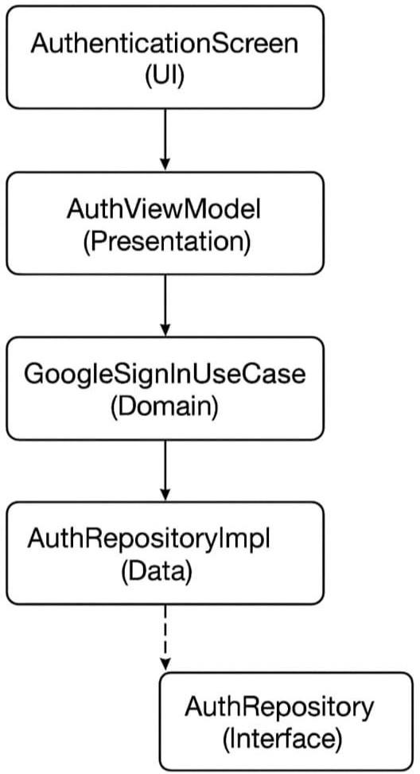
fig1.2

CLASS DIAGRAM (WITH DESCRIPTION)
The Class Diagram illustrates the Clean Architecture principles. For the authentication feature:
      - AuthenticationScreen (UI) depends on AuthViewModel.
      - AuthViewModel (Presentation) depends on GoogleSignInUseCase.
      - GoogleSignInUseCase (Domain) depends on the AuthRepository (Interface).
      - AuthRepositoryImpl (Data) implements AuthRepository and depends on FirebaseAuth. This demonstrates the Dependency Inversion Principle, where high-level modules (UI) do not depend on low-level modules (Data).

Main Classes in RAKSHA System
1. User Class
Attributes:
- userId
- name
- email
- phone
- password
Methods:
- register()
- login()
- enterDestination()
- viewRoute()
- triggerSOS()

2. Route Class
Attributes:
- routeId
- source
- destination
- distance
- estimatedTime
- safetyScore
- Methods:
- calculateRoute()
- getSafeRoute()
- updateRoute()

3.Alert Class
Attributes:
- alertId
- alertType
- message
- timestamp
Methods:
- sendAlert()
- generateAlert()

4. EmergencyContact Class
Attributes:
- contactId
- name
- phone
- relation
Methods:
- addContact()
- removeContact()
- notifyContact()

5. CrimeData Class
Attributes:
- crimeId
- location
- crimeType
- riskLevel
- date
Methods:
- fetchCrimeData()
- updateCrimeData()

6. Feedback Class
Attributes:
- feedbackId
- rating
- comments
Methods:
- submitFeedback()
- updateFeedback()

7. NavigationSystem Class
Attributes:
- currentLocation
- destination
- routeList
Methods:
- findRoutes()
- calculateSafetyScore()
- suggestSafeRoute()

Relationships Between Classes
Association
- User ↔ Route
User selects and views routes

Aggregation
- User ◇── EmergencyContact
Contacts exist independently but linked to user

Composition
- Route ◆── Alert
Alerts depend on route/navigation

Dependency
- NavigationSystem → CrimeData
Uses crime data to calculate safety

Inheritance (Optional Design)
- Alert → DangerAlert / TrafficAlert / SOSAlert
Specialized alert types

Textual Class Diagram Representation

User --------> Route --------> Alert
| |
| ↓
| Feedback
|
◇
EmergencyContact
NavigationSystem ----> Route
NavigationSystem ----> CrimeData

SNAP SHOT
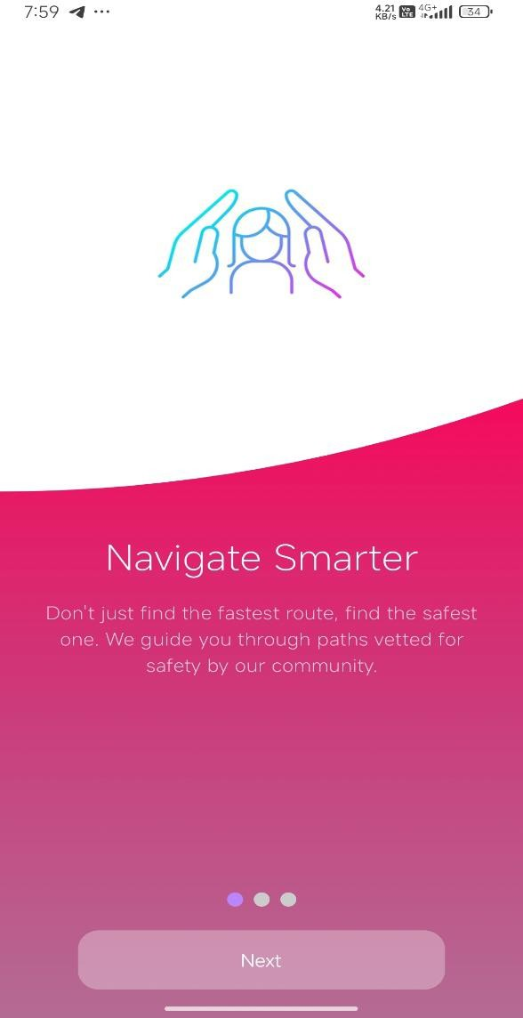
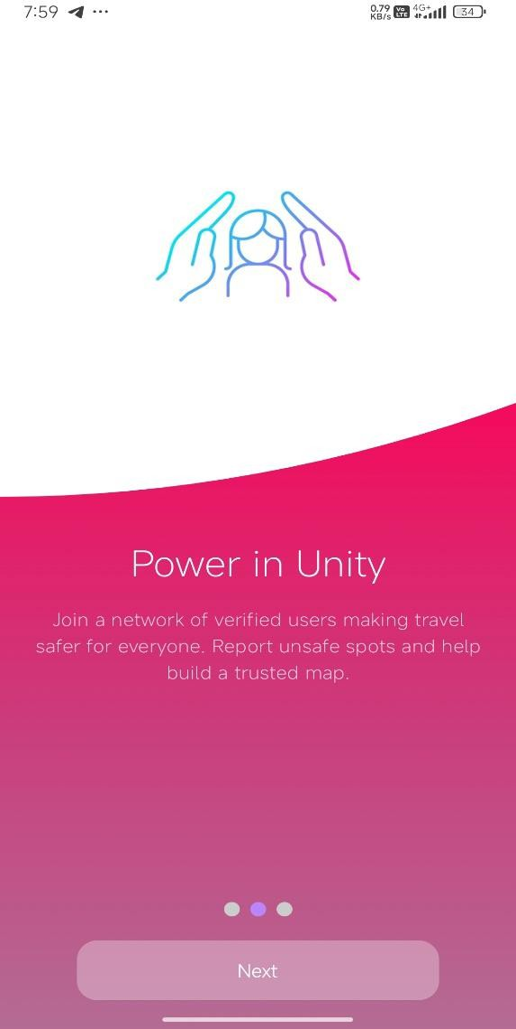
Figure 1
Figure 2

Figure 3
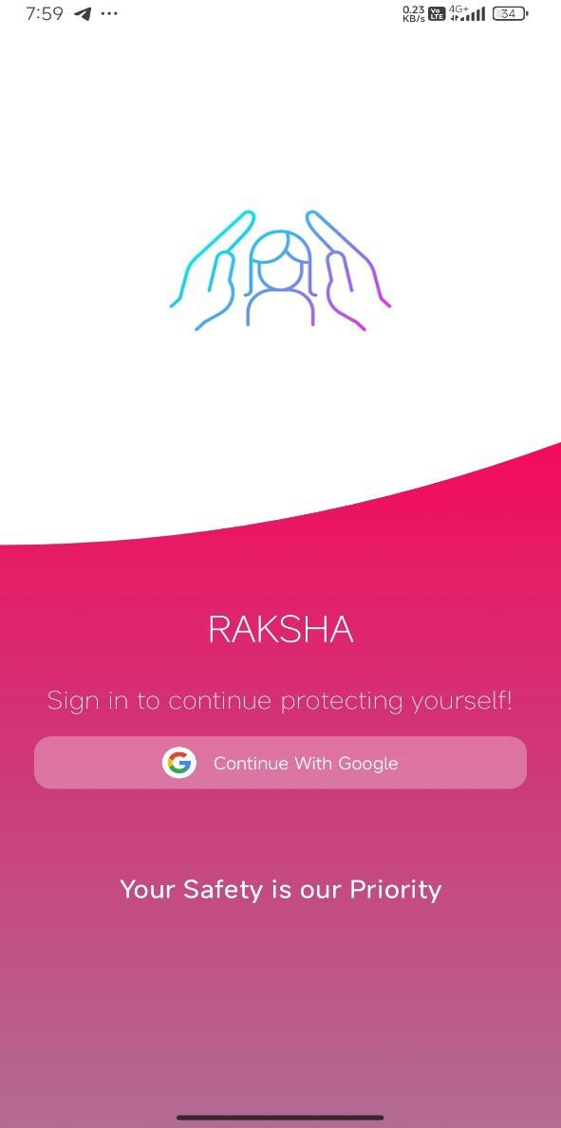
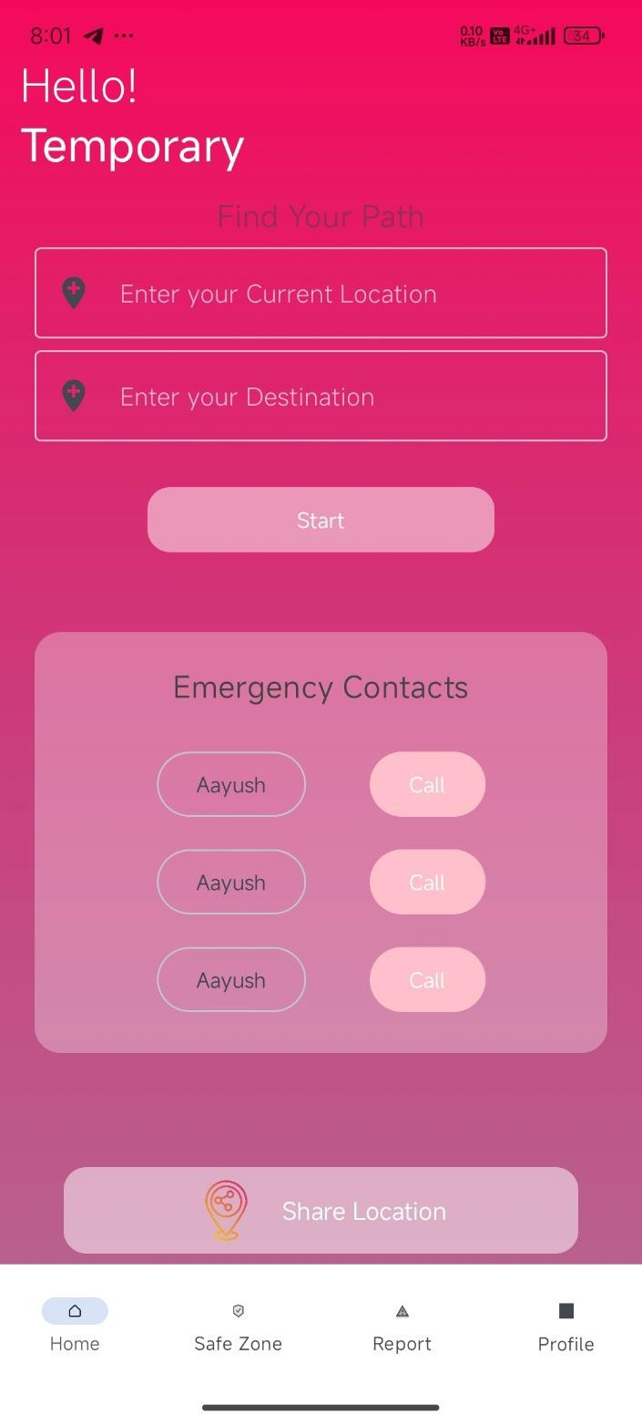
Figure 4

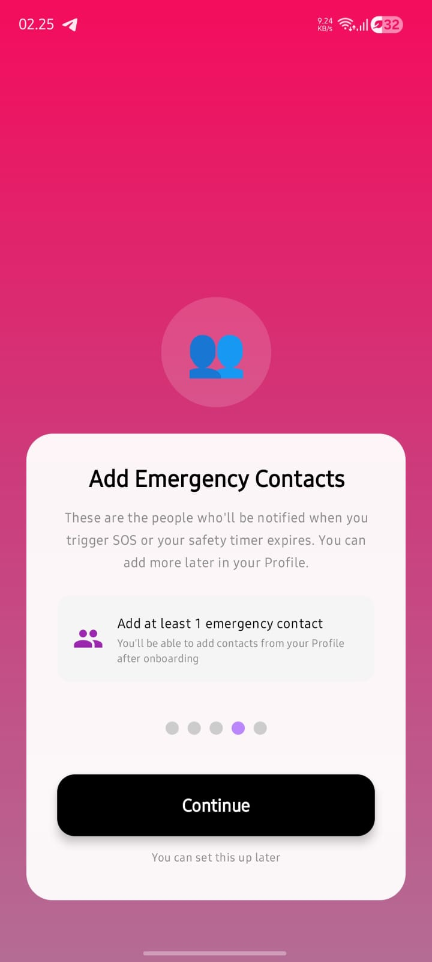
Figure 5
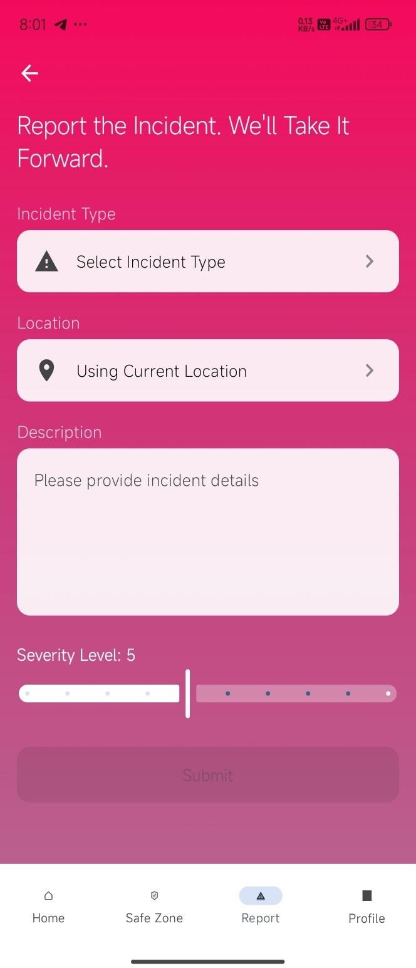
Figure 6

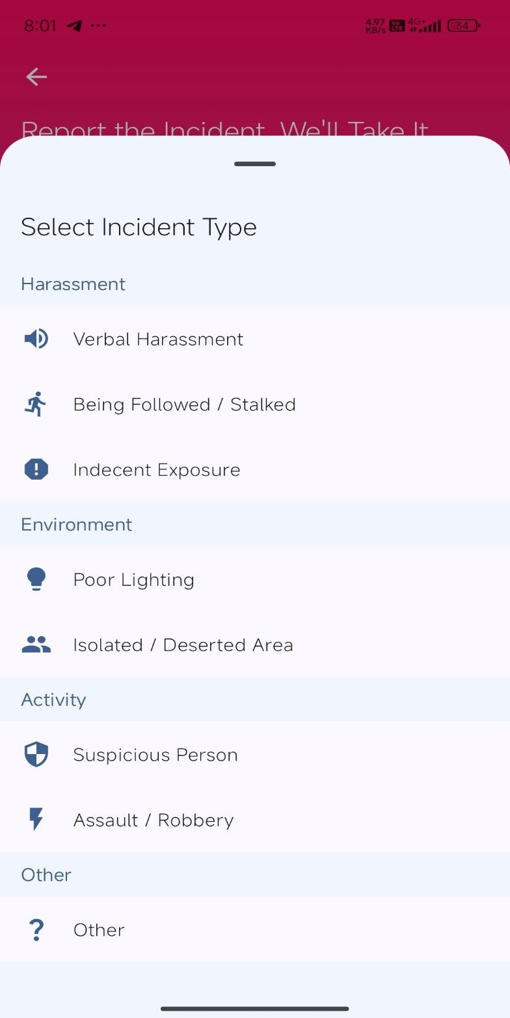
Figure 7

DATA FLOW DIAGRAM (DFD) (Level 0)

Fig2.1
[User]
|
↓
+-------------------+
| RAKSHA System |
+-------------------+
| |
↓ ↓
[Emergency Contact] [Admin]

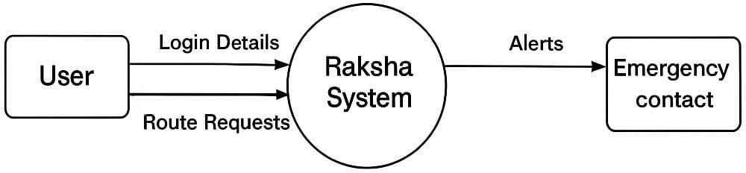

↓
Level 1 DFD (Detailed Diagram)

User → (1) Login/Register → User DB
User → (2) Enter Destination → (3) Route Processing
↓
Route DB & Maps API
↓
(4) Safety Analysis
↓
Crime Data DB
↓
(5) Safe Route Output
↓
User
User → (6) SOS Trigger → (7) Alert System → Emergency Contact
User → (8) Feedback → Feedback DB

Flow Diagram

RAKSHA App Flowchart (Step-by-Step)
Start
↓
User Opens App
↓
Login / Register
↓
Enter Source & Destination
↓
Fetch Routes from Maps API
↓
Analyze Safety (Crime + Traffic + Lighting)
↓
Calculate Safety Score
↓
Select Safest Route
↓
Display Route to User
↓
Start Navigation
↓
[Decision] Any Risk Detected?
↓ Yes ↓ No
Send Alert Continue Navigation
↓ ↓
[Decision] SOS Triggered?
↓ Yes ↓ No
Send Location to Continue Tracking
Emergency Contacts ↓
↓ Reach Destination
↓ ↓
End

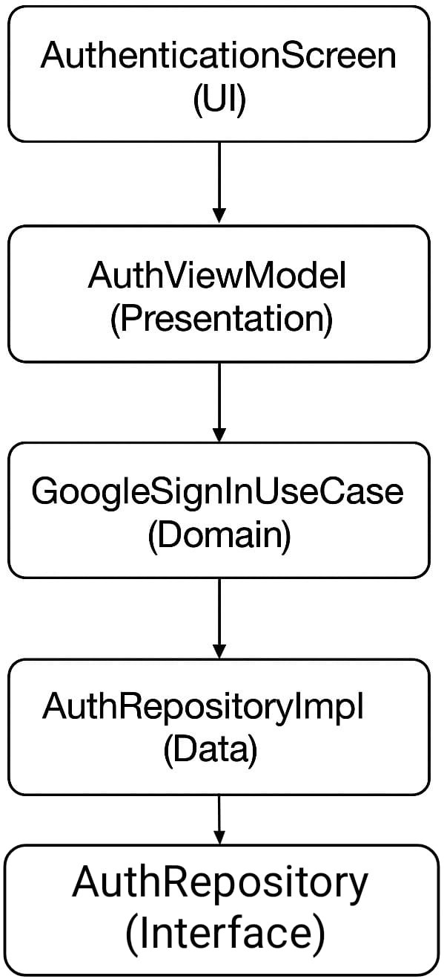

CHAPTER IV: TESTING

ABOUT THE TECHNOLOGY USED
The testing strategy leverages a modern toolset to ensure code quality across all layers of the architecture:
- JUnit 5: Used for local unit testing of the Domain and Presentation (ViewModel) layers.
- MockK/Mockito: Used to create mock objects for repositories and data sources to test Use Cases and ViewModels in isolation.
- Firebase Local Emulator Suite: Used for integration testing. This allows tests to run against a local, offline version of Firebase Authentication and Firestore to validate data flows without an internet connection.
- Jetpack Compose Test: Used for UI testing, allowing the test harness to find composables, simulate user clicks, and assert the UI state.

TESTING
    - UNIT TESTING
Unit tests were performed on individual classes to verify their logic.
      - ViewModel Test: Tested ReportIncidentViewModel by calling onSeverityChange(8f) and asserting that the ViewModel's stateflow correctly updated to a value of 8.
      - Use Case Test: Tested GoogleSignInUseCase by providing a mock AuthRepository that returned a Result.Success and asserting that the use case also returned Result.Success.

INTEGRATION TESTING
Integration tests were performed to verify the interaction between different layers.
      - Auth Flow Test: An instrumented test was written to simulate a Google Sign-In. The test verified that the AuthRepositoryImpl correctly received the token, communicated with the (emulated) Firebase Auth, and returned a success, which was then correctly processed by the AuthViewModel.
      - Reporting Flow Test: A test was written to call ReportIncidentViewModel.onSubmitReport(). The test then queried the Firebase Emulator to assert that a new document was successfully created in the reports collection.

SYSTEM TESTING
End-to-end manual testing was conducted to validate the complete application flow.
- New User Flow: (Pass) User successfully navigated through Onboarding, logged in via Google, and landed on the Main Screen.
- Report Incident Flow: (Pass) Verified user successfully submitted an incident report, and the new pin was visible on the map.

- Timed SOS Flow (Failure Case): (Pass) User started a timed check, let the timer expire, and the system successfully sent an SOS alert to the designated emergency contact.

CHAPTER V: ADVANTAGES AND LIMITATIONS OF THE DEVELOPED SYSTEM

ADVANTAGES OF DEVELOPED SYSTEM
    - Proactive Safety: The app's primary advantage is its proactive nature, helping users avoid danger rather than just reacting to it.
    - Automated Safety Net: The server-side Timed Safety Check provides a robust fail-safe that works even if the user's phone is disabled or out of service.
    - Community-Driven Data: Safety data is real-time and dynamic, reflecting current neighborhood conditions more accurately than static crime statistics.
    - High Scalability & Low Cost: Built on the serverless Firebase platform, the app can scale to millions of users with low operational costs.
    - Modern & Maintainable: The use of Kotlin, Jetpack Compose, and Clean Architecture makes the codebase robust, testable, and easy to maintain.

LIMITATIONS OF DEVELOPED SYSTEM
    - Internet Dependency: Core functionality (maps, reports, alerts) is entirely dependent on an active internet connection.
    - Cold Start Problem: The app's routing feature is not effective in new areas until a critical mass of user-submitted reports is achieved.
    - Battery Consumption: Continuous GPS use for navigation and location tracking is battery-intensive.
    - Platform Limitation: The application is currently developed only for the Android platform, excluding iOS users.
    - Data Integrity: The system relies on SMS verification to build trust, but a determined malicious user could still submit false reports.

1. Enhanced User Safety
RAKSHA prioritizes safe routes over shortest routes by analyzing crime data, lighting conditions, and crowd density.
This reduces the risk of traveling through unsafe or isolated areas.

2. Real-Time Risk Alerts
The app provides instant notifications when a user enters a danger zone, faces traffic issues, or deviates from the safe route.
Helps users take immediate action and stay alert.

3. Emergency SOS Feature
In case of danger, users can activate the SOS button, which:
- Sends live location
- Alerts emergency contacts
- Enables continuous tracking
Provides quick response during emergencies.

4. Intelligent Route Selection
Using AI and smart algorithms, RAKSHA calculates a safety score for each route.
Ensures users always get the most secure path available.

5. Night Travel Safety
The app specially considers night-time risks, such as:
- Poor lighting
- Low population areas
Makes it safer for users traveling late at night.

6. Live Location Sharing
Users can share their real-time location with trusted contacts.
Family or friends can track the journey and ensure safety.

7. Data-Driven Decision Making
RAKSHA uses:
- Crime reports
- Traffic data
- User feedback
Provides accurate and reliable safety analysis.

8. Alternative Safe Routes
If the current route becomes unsafe, the app suggests alternative safer routes.
Ensures continuous safety during the journey.

9. User-Friendly Interface
The app is designed with a simple and intuitive interface.
Easy for all users, including beginners and non-technical people.

10. Continuous Monitoring
RAKSHA continuously tracks user movement and environment.
Provides ongoing protection throughout the journey.

11. Feedback-Based Improvement
Users can report unsafe areas and give feedback.
helps improve system accuracy over time.

12. Social Impact
RAKSHA contributes to:
- Safer cities
- Increased awareness
- Better urban planning (future scope)
Makes it beneficial for society as a whole.

RAKSHA is more than a navigation app—it is a complete safety solution that combines technology, real-time data, and intelligent decision-making to provide secure, reliable, and user-friendly travel assistance.

CHAPTER VI: CONCLUSION AND SUGGESTIONS FOR FURTHER WORK

CONCLUSION
The "Raksha" project successfully delivers a modern, scalable, and effective solution to the persistent problem of personal safety in urban environments. By integrating community-driven data with proactive and automated safety features, the application provides a tangible tool that empowers users to make safer decisions and provides a crucial safety net. The use of a modern stack (Kotlin, Compose, Firebase, Clean Architecture) resulted in a high-quality, maintainable, and testable application.

The RAKSHA – Safest Route Finder App is an innovative solution that focuses on user safety during travel by combining navigation with real-time risk analysis. Unlike traditional navigation systems, it prioritizes safe routes over shortest or fastest paths, making it highly useful for daily commuters, especially in vulnerable situations.
By integrating technologies such as GPS, AI, real-time data analysis, and alert systems, the app ensures that users are continuously informed about their surroundings and potential risks. Features like danger alerts, live tracking, and SOS emergency support enhance the reliability and effectiveness of the system.
Overall, RAKSHA provides a smart, secure, and user-friendly platform that not only improves travel safety but also contributes toward building a more aware and safer society.

SUGGESTIONS FOR FURTHER WORK
While the current system is a robust foundation, its potential can be significantly expanded. Future work could include:
    - iOS Version: Developing a parallel application for iOS to achieve platform parity and expand the user base.
    - Integration of Official Data: Augmenting crowdsourced reports by integrating official public police data feeds (e.g., crime statistics).
    - AI/ML Route Analysis: Implementing a machine learning model to weigh factors like time of day and historical data to generate more intelligent route suggestions.
    - Live Location Sharing ("Walk With Me"): Adding a feature that allows a user to temporarily share their live location with a specific contact.
    - Offline Maps and "Safe Zone" Caching: Caching safety data for a user's local area to provide limited functionality when their internet connection is unstable.

1. Improve Data Accuracy & Reliability
The effectiveness of RAKSHA depends heavily on the quality of data (crime reports, traffic updates, etc.).
- Integrate verified government crime databases
- Use real-time crowd-sourced data from users
- Regularly update datasets to avoid outdated information
This will ensure more accurate safety predictions and route suggestions.

2. Enhance User Interface (UI/UX)
A simple and intuitive interface is crucial for user adoption.
- Use clear icons and color-coded safety indicators
- Provide easy navigation flow for all age groups
- Add dark mode for night usability
This improves user experience and accessibility.

3. Optimize for Low Connectivity
Many users may travel in areas with weak internet.
- Implement lightweight data processing
- Use cached maps and routes
- Provide limited offline functionality
Ensures the app works reliably even in rural or low-network areas.

4. Strengthen Security & Privacy
Since the app deals with sensitive location data:
- Use end-to-end encryption
- Secure user authentication (OTP/2FA)
- Allow users to control data sharing permissions
Builds trust and protects user data.

5. Multi-Language Support
To make the app accessible to a wider audience:
- Add support for regional languages
- Provide voice instructions in multiple languages
Makes the app more inclusive and user-friendly.

6. Performance Optimization
- Reduce app loading time
- Optimize backend response speed
- Improve battery efficiency during GPS tracking
Ensures smooth and efficient performance.

Future Work
1. Advanced AI-Based Risk Prediction
- Use machine learning models to predict unsafe situations before they occur
- Analyze patterns like time, location, and past incidents
Makes the app proactive instead of reactive.

2. Integration with Government & Police Systems
- Direct connection with law enforcement databases
- Real-time alerts from police systems
Enables faster emergency response and accurate data.

3. Voice Assistance & Smart Alerts
- Voice-guided navigation
- Audio warnings like: “Unsafe area ahead”
Useful for hands-free and distraction-free usage.

4. Wearable Device Integration
- Connect with smartwatches or fitness bands
- Quick SOS trigger from wearable devices
Enhances accessibility during emergencies.

5. Full Offline Mode
- Pre-download maps and safety data
- Provide basic routing without internet
Useful in remote or network-free areas.

6.safety network.
Community-Based Reporting System
- Users can report:
  - Unsafe areas
  - Suspicious activity
- Ratings for route safety
Creates a collaborative safety network.

7. AI-Based Image & Video Analysis (Advanced)
- Analyze surroundings using camera
- Detect unsafe situations automatically
Adds an extra layer of intelligent safety detection.

8. Integration with Smart Vehicles (Future Scope)
- Connect with car systems
- Provide safety alerts directly on vehicle dashboard
Useful for drivers and long-distance travelers.

9. Environmental & Weather Integration
- Include weather conditions like fog, rain, etc.
Helps avoid dangerous environmental situations.

10. Expansion to Smart City Ecosystem
- Integration with smart city infrastructure
- Use IoT sensors for real-time monitoring
Makes RAKSHA part of a larger smart safety network.

REFERENCES

(You would list your references here, for example:)
- Google. (2023). Firebase Documentation. Retrieved from https://firebase.google.com/docs
- Google. (2023). Jetpack Compose. Retrieved from https://developer.android.com/jetpack/compose
- Martin, R. C. (2017). Clean Architecture: A Craftsman's Guide to Software Structure and Design. Prentice Hall.
- Safetipin. (2023).

